Python and MongoDB test

The Task
You should create a backend project to manage customer subscriptions to products. The project should be implemented in Python and a MongoDB database.

Requirements:
- The database should include two main collections: customers and products, but you can add as many additional collections as needed.
- Each customer can be subscribed to many products.
- Some products allow customization. That is, the client can request custom styles or behavior. The system should allow these customizations and provide an easy way to include them for every product subscription.
- Each subscription has an expiration date. According to the expiration date, the subscription could be active or expired
- You should implement an API that includes the following operations:
  - Register: to add a new customer
  - AddProduct: to add a new product
  - Subscribe: allows a customer to subscribe to a specific product with a specific customization and expiration date.
  - GetSubscriptionStatus: returns whether the subscription is active or expired
  - GetSettings: returns the specific settings of a subscription
  - EditSubscription: modifies the specific settings of a subscription
  - ExtendSubscription: set a new expiration date for a subscription
- The project should be published as a public repository on Github and you should provide the link so we can review it. Include a Readme with the basic set up instructions.

Some useful ideas
Assume that one of the possible products is an accessibility widget that we install in the customer’s website. See the picture below: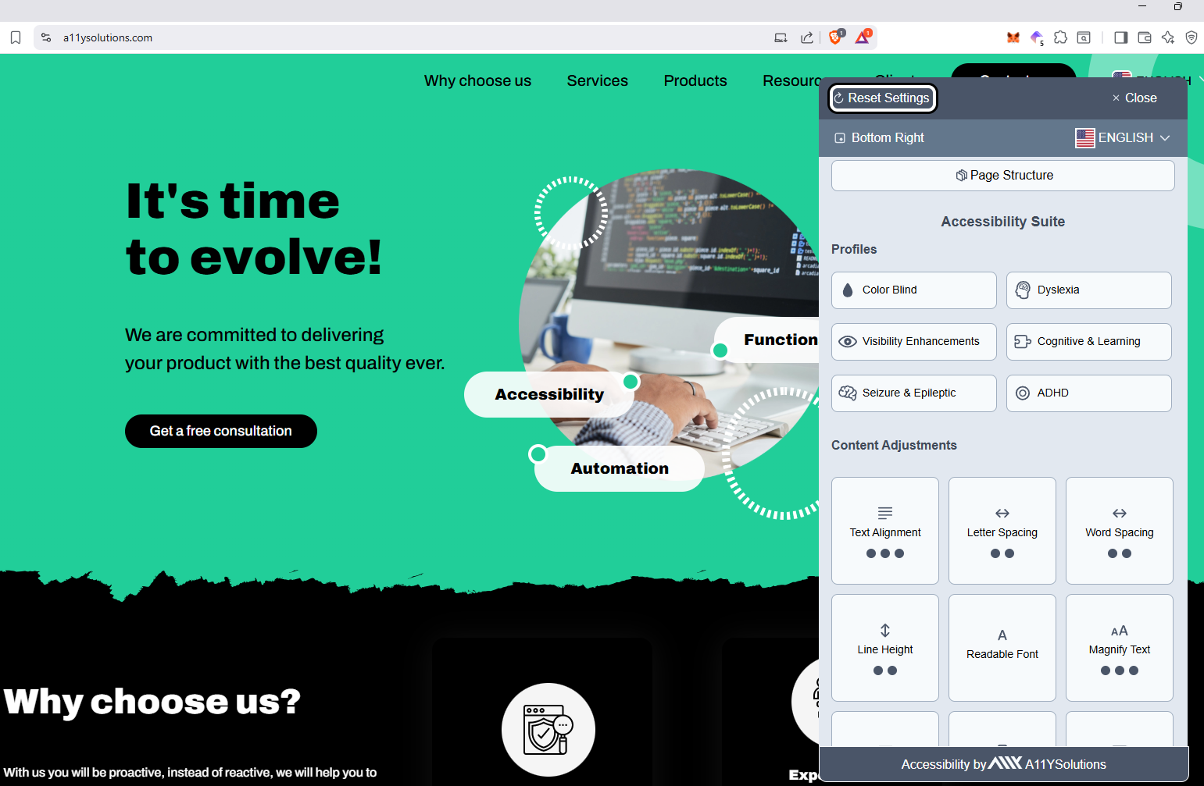

The customers can modify the color of the different sections, buttons, texts, etc. They can also modify the default language and default position of the widget on the website. The configuration for each client looks something like this:

{
“clientId”: <id>
“productId” <widget id>
“topBarColor”: #fffffff
“topBarBackgroundColor”: “#000000”
“topBarButtonBackgroundColor”: “#000000”
…
“positionIndex”: 0
“defaultLang”: “en”
}

This is just to give you an example of what a product customization looks like. Feel free to create other products and customizations that you like.

We would like the API to be implemented with Flask, but feel free to use any other library/framework you feel comfortable with.

Bonus Points
The following are not requirements but extras that can boost the possibility of being accepted for the position.
- Containerize the entire project. We value the use of Docker, Docker Compose and/or Kubernetes
- Create a frontend for the project. Implementing it on React is a plus.
- Secure the API with api keys or any other authorization/authentication method.
- Include a prize and a periodicity in the subscription and modify the API so it becomes easy to calculate financial stats like:
  - Monthly Recurring Revenue (MRR): total revenue / total months
  - Annual Recurring Revenue (ARR): total revenue / total years
  - Average Revenue Per User (ARPU): total revenue / number of users
  - Customer Lifetime Value (CLV): avg purchase * purchase frequency * client lifespan
  - Customer Retention Rate (CRR): given a specific time range: clients at the end - new customers / clients at the beginning
  - Churn Rate (CR): given a specific time range: lost customers / customers at the beginning
  - Average Order Value (AOV): total revenue / number of orders
  - Repeat Purchase Rate (RPR): number of returning customers / number of customers
- If you calculate some of the stas of the previous point, you can also create frontend visualizations of these stats.
- Add testing (we use pytest) ← Highly valued
- Add some CICD pipelines (we use Github Actions)

Final Recommendations
Do not hesitate to ask if you have any questions or if you don’t understand something!

After you deliver your solution, we’ll schedule a call to have a discussion about the project. View this as an extra opportunity to show what you know. So, if you couldn’t do something or you are not entirely happy with your implementation, be ready to show us your expertise in the call.

We don’t enforce a strict deadline for the project but consider that we need to increase our team ASAP. So don’t try to implement every bonus point and every stat or wait to have the perfect project to deliver it. Just do what you know how to do and then show us the rest in the review call.

Feel free to add your own features and twist the requirements a little bit if you get stuck or consider that you are enriching the project with your approach. Also, feel free to use other tools than the recommended ones as long as you use Python and Mongo DB.

Good Luck!

